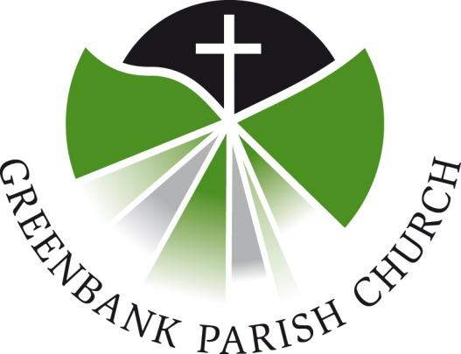
Social Media Guidelines/Reference
May 2018
To Be Revised: May 2020

In what follows you will find some guidelines for duties as an administrator of Greenbank’s Social Media accounts (currently the website and Facebook page). Please review this in tandem with the Publicising Events & Activities document, found on the Greenbank Website. The goal with the following is to provide insight as to the current administrators, guidance on ‘in-house’ style, and recommendations on frequency of posting.
The aim with the Facebook page is, essentially, about outreach. Social media is a way to showcase the day-to-day activities of the Church to both our physical and our digital neighbourhoods and invite people into the church. To that end, our aim is to have posts which on the one hand illustrate the lively and diverse activities of Greenbank, yet on the other hand not to flood our digital neighbourhood.
Current Administrators
Facebook: Martin Ritchie, Steve Chaffee, Hazel Macaulay, Rachel McWilliam,
Alison Murison, Rona Sommerville
Website: Rona Sommerville, Alison Murison, John Murison
Posts/Events
- Please refrain from ‘I/mine’ in favour of ‘we/our’. Eg. ‘It’s a beautiful day at our church picnic!’ With photo attached.
- As one of the public faces of the Church, posts should seek to avoid potentially offensive language.
- In line with Data Protection Guidelines, no photos may be posted of persons without their expressed permission, or the permission of their parents/guardians in the case of minors.
- For impact, events should be first posted with three weeks’ lead-time.
Text Content of Posts
Please keep posts identical in brevity to intimations which would normally go into the Orders of Service on Sunday. Please send the text for digital intimations in the first instance to the Church Office, Steve Chaffee, or Alison Murison. Additionally, please include the date(s) upon which you’d like an intimation to appear.
Frequency
Each administrator is asked to post at least once a month, but no more than four times in a month.
Other Resources
Church of Scotland Social Media Tips

